**Flood Inundation Mapping Project Using HEC-RAS Model**

Abstract

The Flood Inundation Mapping project utilized the Hydrologic Engineering Centre's River Analysis System (HEC-RAS) to analyze flood patterns in Kerala's Chalakudy River region. This study focused on creating a one-dimensional flood mapping system, particularly examining the downstream area near the Arangali CWC discharge measuring station. The project's findings provide crucial insights for disaster management and urban planning, especially in light of the devastating floods of 2018.

Project Background and Objectives

Kerala has faced significant challenges with flooding in recent years, experiencing an alarming increase in both the frequency and magnitude of flood events. These disasters have resulted in severe impacts on human life, property damage, and environmental degradation. The project aimed to develop comprehensive flood inundation mapping to assist in mitigating these impacts and improving disaster preparedness.

The study area encompasses the downstream regions of Chalakudy River, specifically focusing on thirteen panchayats in the Thrissur district of Kerala: Aloor, Annamanada, Athirappilly, Ayyambuzha, Chalakudy, Kadukutty, Karukutti, Koratty, Kuzhur, Meloor, Mukkannoor, Parakkadavu, and Pariyaram. This region was selected due to its historical vulnerability to flooding and its significance in the 2018 flood event.

Methodology and Implementation

The project methodology involved a systematic approach to data collection and analysis. The foundation of the study relied on a Digital Elevation Model (DEM) with 30m resolution, obtained from ISRO-Bhuvan, which provided essential terrain data for the study area. Daily discharge measurements from January 1 to December 31, 2018, were collected from the Arangali CWC discharge measuring station, offering crucial hydrological data for the analysis.

The technical implementation began with defining the study area using QGIS with OSM plugin. The terrain and geometry preparation was conducted in RAS Mapper, utilizing the ESRI Projection file 32643 WGS 1984/UTM Zone 43N coordinate system and ArcGIS World Imagery as the base map. The model incorporated specific parameters, including Manning's Roughness Coefficient values of 0.03 for the main river and 0.035 for the right and left banks, with a downstream boundary condition normal slope of 0.015.

Results and Discussion

The analysis revealed critical findings about the flood patterns in the region. The peak discharge was recorded on August 16, 2018, with notable observations at two key sections. Section 2219 showed a Froude number of 2.64 and a velocity head of 5.17m, while Section 64 exhibited a Froude number of 1.5 and a velocity head of 2.98m. The presence of Froude numbers greater than 1 indicated supercritical flow conditions in these sections, highlighting areas of potential concern during flood events.

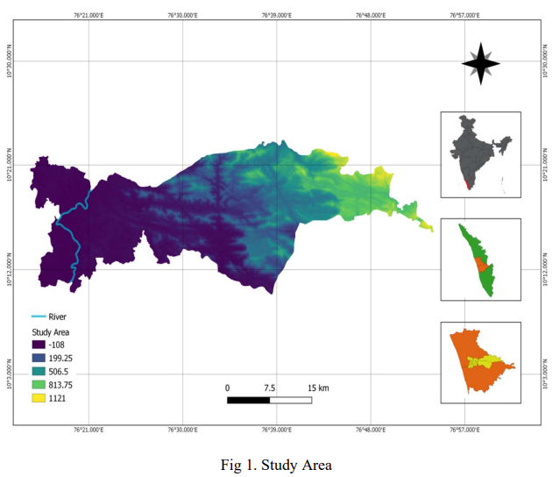

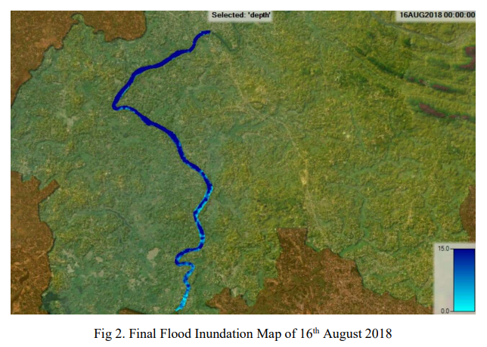

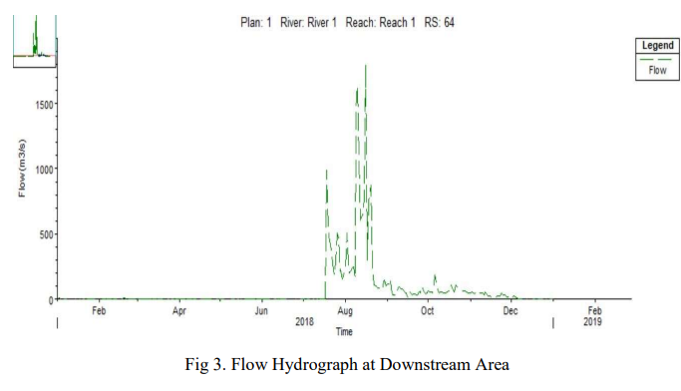

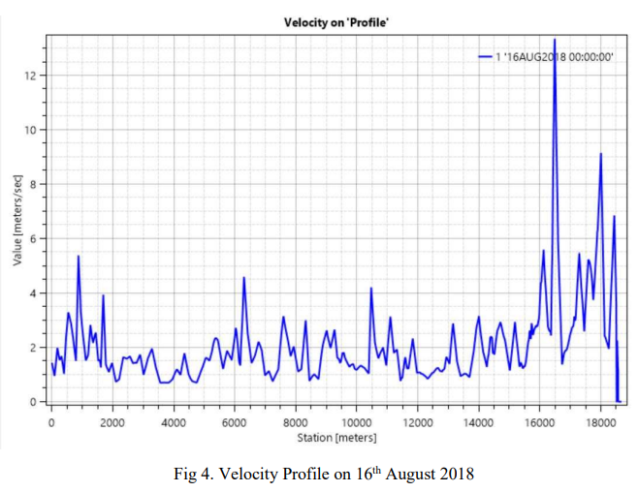

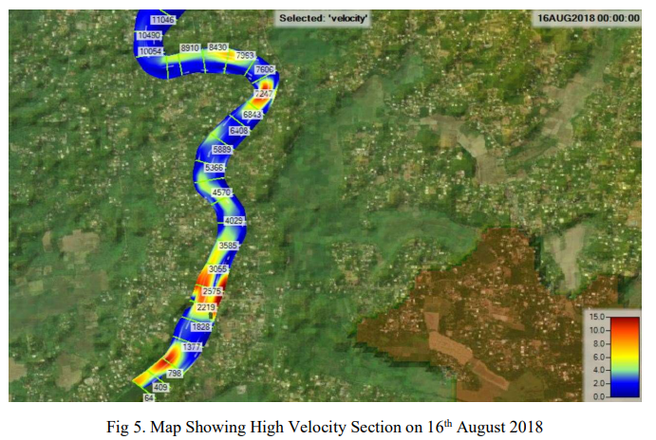

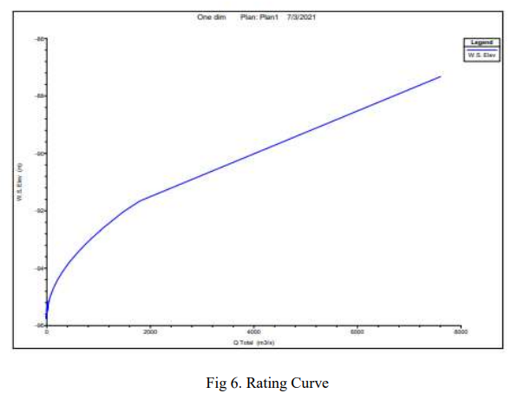

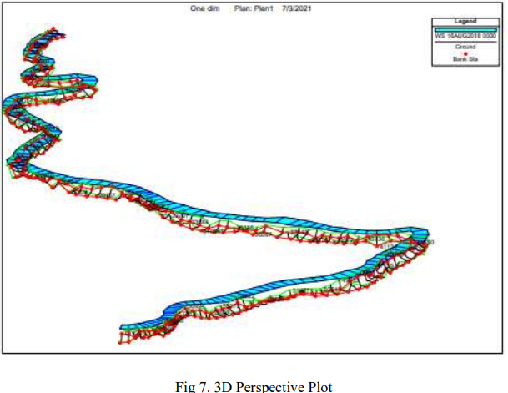

The project produced several valuable visualization tools, including a detailed flood inundation map for August 16, 2018, flow hydrographs, velocity profiles, and a high-velocity section map. These visualizations provide essential information for understanding flood patterns and identifying critical areas requiring attention during flood events.

Applications and Future Development

The findings of this study have immediate applications in disaster management and urban planning. The flood inundation maps serve as crucial tools for emergency planning, flood mitigation strategies, and risk assessment. In urban planning, these results can guide decisions about land use, infrastructure development, and zoning considerations.

Looking forward, the project opens up several avenues for future development. There is potential for creating more sophisticated evacuation plans and optimizing emergency response routes. The integration of real-time flood monitoring systems could enhance the predictive capabilities of the model. Further research could focus on incorporating additional data sources and improving prediction models to provide more accurate and timely flood warnings.

References

This study builds upon previous research in flood modeling and analysis, particularly drawing from the work of Pathan and Agnihotri (2020) on 2-D unsteady flow modeling in the Purna Basin, and Bhandari et al. (2017) on flood inundation mapping in the Brazos River watershed. These studies provided valuable methodological insights and comparative perspectives for our analysis.